INGLESE:
EXERCISE Number 1 (per chi non ha la possibilità di stampare, far ricopiare sul quaderno i nomi delle diverse parti del corpo e accanto ad essi scrivere la traduzione in italiano) es: HEAD: testa)
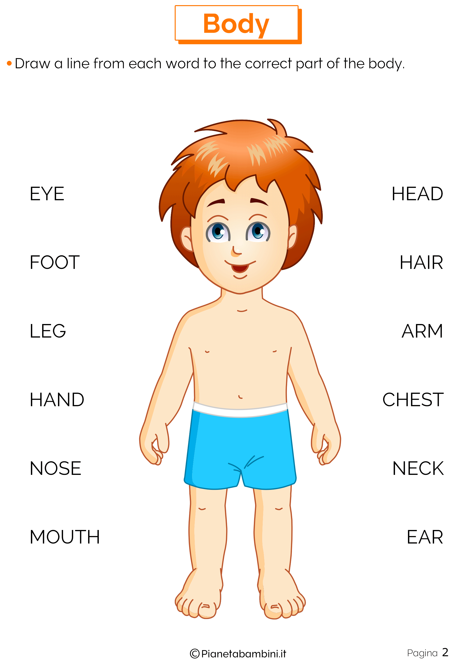

EXERCISE Number 2
Leggi, traduci, ripeti tante volte le seguenti frasi e fatti, infine, interrogare dalla mamma o dal papà: (per chi non ha la possibilità di stampa, eseguire l’esercizio, per favore, sul quaderno)
1-WHAT TIME IS IT?
___________________________________________________
2-WHAT ARE YOU WEARING TODAY?
___________________________________
3-WHAT DAY IS IT TODAY?
_______________________________________________
4-WHAT’S THE WEATHER LIKE TODAY?
_________________________________
5-WHERE IS THE FRIDGE? IT’S IN THE KITCHEN: ________________________________________________________________________________________________________________________________________
6-THERE IS: ____________________ THERE ARE: _____________________
7-WHAT SEASON IS IT? _________________________________________________
A- It’s Spring B- It’ s Summer C- It’s Winter D- It’s Autumn
8-ARE YOU READY?
___________________________________________________
9-WHAT COLOUR IS IT?
________________________________________________
10-WHAT IS YOUR FAVORITE ANIMAL?
_________________________________
11-HOW OLD ARE YOU?
_________________________________________________
12-AFTER: ______________________ BEFORE: _______________________

EXERCISE Number 3
SEGNA LA RISPOSTA ESATTA E RIPETI TANTE VOLTE I VOCABOLI: (per chi non ha la possibilità di stampa, eseguire l’esercizio sul quaderno in questo modo: Es: Numero 1= B…)
1-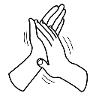 | - Wash your hands  - Clap your hands  - Brush your teeth
2-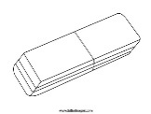 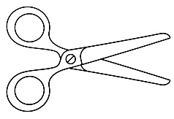 | - I have a glue but I have not scissors  - I have a rubber but I haven’t scissors  - I have a ruler but I haven’t scissors
3- 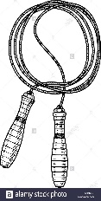 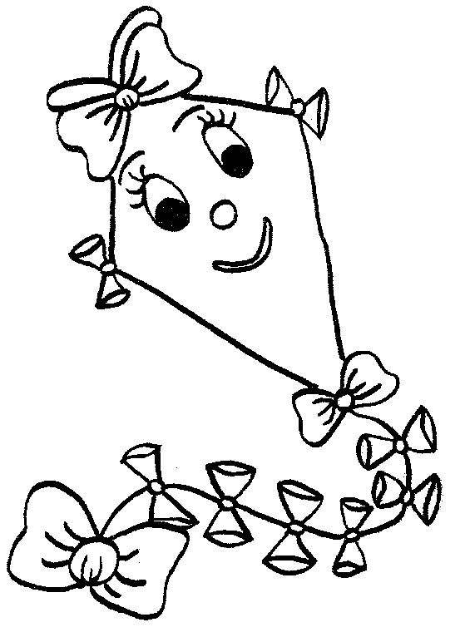 | - I have a rope but I have not a plane  - I have a plane but I haven’t a doll  - I have a kite but I haven’t a rope
4-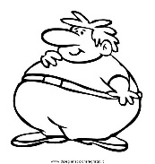 | - FAT MAN  - THIN MAN  - FAT WOMAN
5-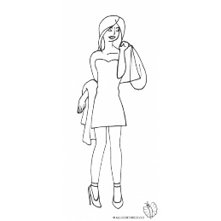 | - A tall, thin and young woman  - A tall, thin and old woman  - A tall, thin and young man
6- 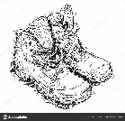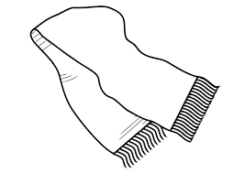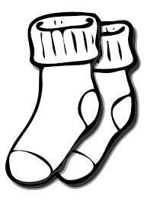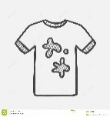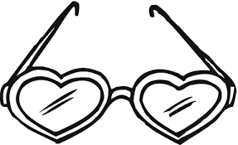 | IN THIS PICTURE I SEE:  - New shoes, a scarf, big socks, a clean shirt, sunglasses.  - Old shoes, a hat, small socks, a dirty shirt, sunglasses.  - Old shoes, a scarf, small socks, a dirty shirt, sunglasses.
7- 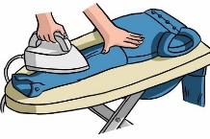 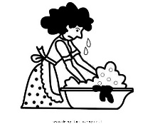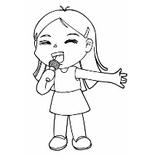 | - I iron and I sing  - I iron and I wash  - I wash and I sing
8-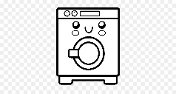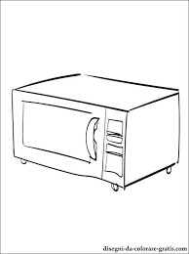 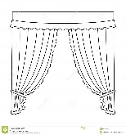 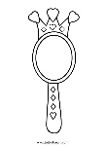 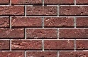 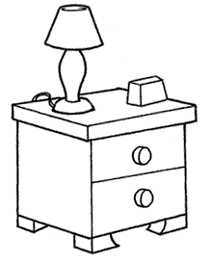 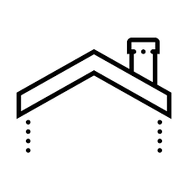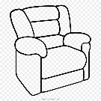 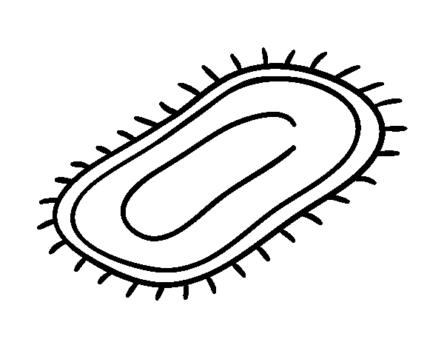 | IN THIS PICTURE YOU CAN SEE:  - A washing machine, an oven, curtains, a mirror, a wall, a bedside table, a roof and chimney, an armchair, a carpet.  - A bed, a washing machine, an oven, a wardrobe, a roof, a fridge, an armchair.  - A washing machine, an oven, curtains, a door, a wall, a bedside table.
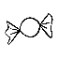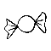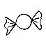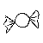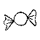9- | HOW MANY CANDIES ARE THERE?  - There are twenty- four candies  - There are twenty- eight candies  - There is twenty- eight candies
10- 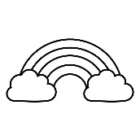 | HOW MANY RAINBOWS ARE THERE?  - There is one rainbow  - There are twelve rainbows  - There are one rainbow
11- 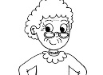 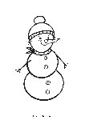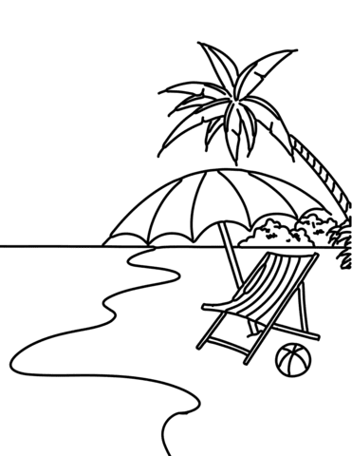 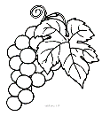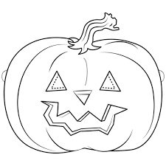 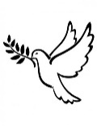 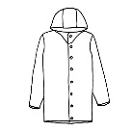 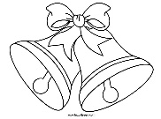 | YOU CAN SEE:  - GRANDMOTHER- SNOWMAN- SKY- GRAPES- CHERRY- DOVE- RAINCOAT- REINDEER  - AUNT- SNOWFLAKES- SUN- GRAPES- PUMPKIN- PIG- JUMPER- BELLS  - GRANDMOTHER- SNOWMAN- BEACH- GRAPES- PUMPKIN- DOVE- RAINCOAT- BELLS

EXERCISE N. 4
YOU ANSWER (per chi non ha la possibilità di stampa, rispondere, per favore, sul quaderno)
WHAT IS THE OPPOSITE OF YOUNG? __________________
WHAT IS THE OPPOSITE OF DIRTY? _________________
WHAT IS THE OPPOSITE OF BIG? _____________________
WHAT IS THE OPPOSITE OF TALL? ____________________
WHAT IS THE OPPOSITE OF THIN? _____________________

